**Lab Exercise No:1**

**Exercise Objective(s): The concept of inheritance**

**Exercise: Create a class called Vehicle. Create subclasses like Truck, Bus, Car etc. Add common methods in the base class and specific methods in the corresponding class. Create a class called Road and create objects for the Truck, Car, Bus etc and display the appropriate message.**

**Code:**

package com.oops;

class Vechicleoops{

String name;

String number;

String color;

Vechicleoops(String name, String number, String color)

{

this.name=name;

this.number=number;

this.color=color;

System.out.println("Name of the Vechicle:"+name+"\nNumber of the Vechicle: "+number+"\nColour of the Vechicle: "+color);

}

}

class Truck extends Vechicleoops{

String name;

String number;

String color;

Truck(String name, String number, String color)

{

super(name, number, color);

}

public void VarietyOfTrucks()

{

System.out.println("Sand_Load");

System.out.println("Grains_Load");

System.out.println("Vechiles_Load");

System.out.println("Stone_Load");

System.out.println("Parcel_Services");

System.out.println("==========================================================================");

}

}

class Bus extends Vechicleoops{

String name,number,color;

Bus(String name, String number, String color)

{

super(name,number,color);

}

public void LocationToTravel()

{

System.out.println("Salem To Hyderbad" +" "+ " Hyderbad to Salem");

System.out.println("Salem To Chennai" +" "+ " Chennai to Salem");

System.out.println("Chennai To Hyderbad" +" "+ " Hyderbad to Chennai");

System.out.println("Banglore To Chennai" +" "+ " Chennai to Banglore");

System.out.println("==========================================================================");

}

}

class Car extends Vechicleoops{

String name,number,color;

Car(String name,String number,String color)

{

super(name,number,color);

}

public void varietyOfSeaters()

{

System.out.println("2 Seaters");

System.out.println("4 Seaters");

System.out.println("5 Seaters");

System.out.println("7 Seaters");

System.out.println("==========================================================================");

}

}

class Bike extends Vechicleoops{

Bike(String name, String number, String color) {

super(name, number, color);

}

public void varientOfBikes()

{

System.out.println("v2");

System.out.println("v3");

System.out.println("v4");

System.out.println("==========================================================================");

}

}

public class Vehicleoops {

public static void main(String[] args) {

Truck obj=new Truck("Saro","TN54A5543","Red");

obj.VarietyOfTrucks();

Bus obj1=new Bus("JTS","TN54A2345","Merron");

System.out.print(obj1.color);

obj1.LocationToTravel();

Car obj2=new Car("NANO","TN54Q8473","Black");

obj2.varietyOfSeaters();

Bike obj3=new Bike("R15","TN54U8473","Silver");

obj3.varientOfBikes();

}

}

Output:

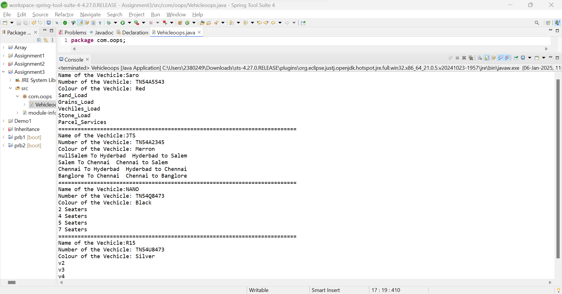

**2.Write a Java program to Implement single inheritance.**

**Code:**

**package** com.oops;

**class** Calculator{

**public** **int** add(**int** number1,**int** number2)

{

**return** number1+number2;

}

**public** **int** sub(**int** number1,**int** number2)

{

**return** number1-number2;

}

}

**public** **class** Single_Inheritance **extends** Calculator{

**public** **static** **void** main(String[] args) {

Single_Inheritance obj=**new** Single_Inheritance();

**int** add=obj.add(5,3);

System.***out***.println("Addition of 2 Numbers is: "+add);

**int** sub=obj.sub(5,3);

System.***out***.println("Subtraction of 2 Numbers is: "+sub);

**int** mul=obj.mul(5,3);

System.***out***.println("Multiplication of 2 Numbers is: "+mul);

**int** div=obj.div(5,3);

System.***out***.println("Division of 2 Numbers is: "+div);

}

**public** **int** mul(**int** number1,**int** number2)

{

**return** number1*number2;

}

**public** **int** div(**int** number1,**int** number2)

{

**return** number1/number2;

}

}

**Output:**

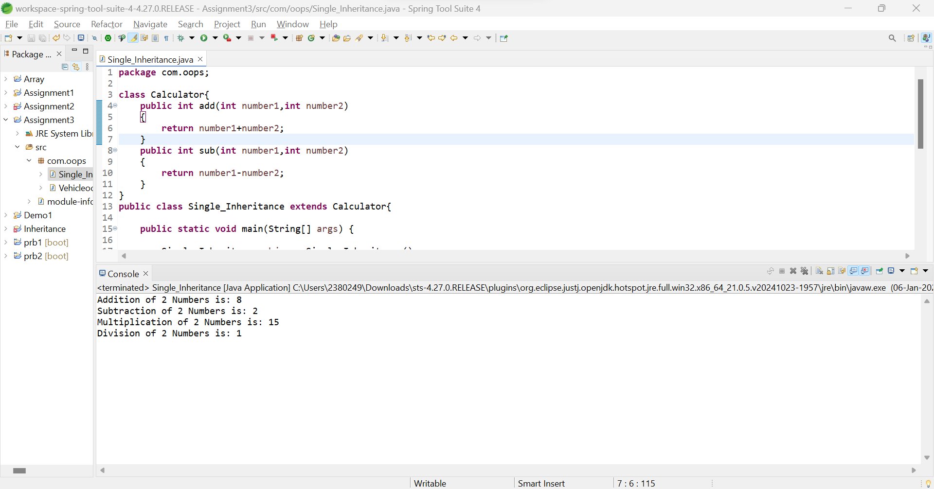

**3. Write a Java program to based on the multilevel inheritance in Java.**

**Code:**

package com.oops;

import java.util.Scanner;

class Square

{

public void perimeter(int number1)

{

System.out.println("Perimeter of Square is: "+(4*number1));

}

public void area(int number1)

{

System.out.println("Area of Square is: "+(number1*number1));

}

}

class Rectangle extends Square

{

public void perimeter(int length,int breadth)

{

super.perimeter(length);

System.out.println("Perimeter of Rectangle is: "+(2*(length+breadth)));

}

public void area(int length,int breadth)

{

super.area(length);

System.out.println("Area of Rectangle is: "+(length*breadth));

}

}

public class Shape extends Rectangle{

public static void main(String[] args) {

Scanner sc=new Scanner(System.in);

System.out.println("Enter the Number1: ");

int number1=sc.nextInt();

System.out.println("Enter the Number2: ");

int number2=sc.nextInt();

Shape obj=new Shape();

obj.perimeter(number1,number2);

obj.area(number1,number2);

}

}

**Output:**

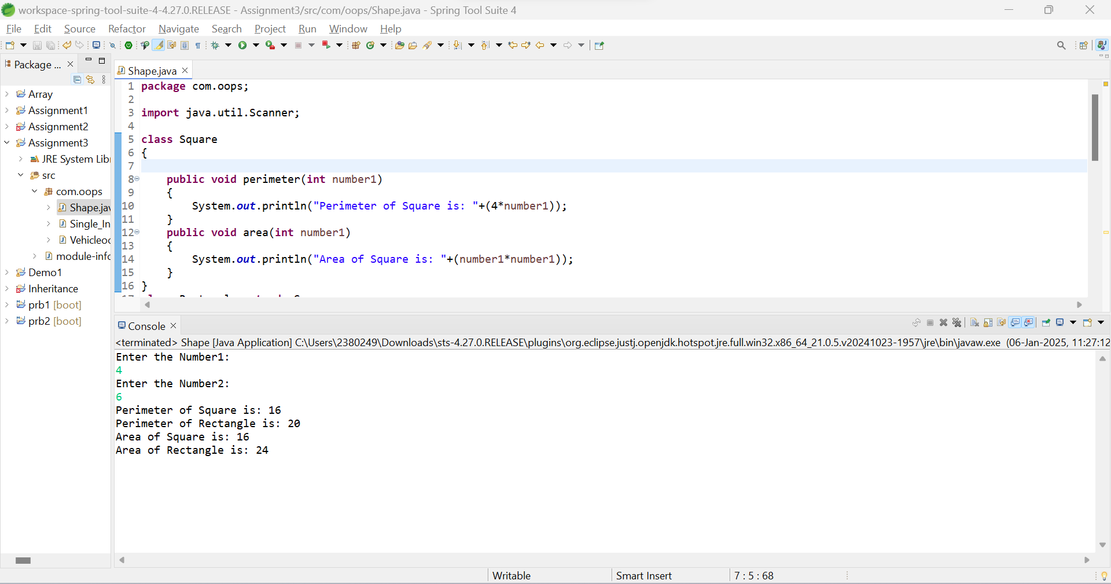

**4. Create a class named 'Member' having the following members:**

**Data members**

**1 - Name**

**2 - Age**

**3 - Phone number**

**4 - Address**

**5 - Salary**

**It also has a method named 'printSalary' which prints the salary of the members.**

**Two classes 'Employee' and 'Manager' inherits the 'Member' class.**

**The 'Employee' and 'Manager' classes have data members 'specialization' and 'department' respectively.**

**Now, assign name, age, phone number, address and salary to an employee and a manager by making an object of both of these classes and print the same.**

**Code:**

package com.oops;

import java.util.Scanner;

class Member_Details{

String name;

byte age;

long phone_no;

String address;

double salary;

Member_Details(String name, byte age, long phone_no, String address, double salary)

{

this.name=name;

this.age=age;

this.phone_no=phone_no;

this.address=address;

this.salary=salary;

}

public void printSalary()

{

System.out.println("The salary of the Member is: "+salary);

}

}

class Employee extends Member_Details{

String specialization;

Employee(String name, byte age, long phone_no, String address, double salary,String specialization)

{

super(name,age,phone_no,address,salary);

this.specialization=specialization;

}

public void displayDetails() {

System.out.println("Name of the Employee: "+name.toUpperCase());

System.out.println("Age of the Employee: "+age);

System.out.println("Contact Number of the Employee: "+phone_no);

System.out.println("Address of the Employee: "+address);

printSalary();

System.out.println("Specialization of the Employee: "+specialization);

System.out.println("=============================================================================");

}

}

class Manager extends Member_Details{

String department;

Manager(String name, byte age, long phone_no, String address, double salary,String department)

{

super(name,age,phone_no,address,salary);

this.department=department;

}

public void displayDetails() {

System.out.println("Name of the Employee: "+name.toUpperCase());

System.out.println("Age of the Employee: "+age);

System.out.println("Contact Number of the Employee: "+phone_no);

System.out.println("Address of the Employee: "+address);

printSalary();

System.out.println("Specialization of the Employee: "+department);

System.out.println("=============================================================================");

}

}

public class Member {

public static void main(String[] args) {

Scanner sc=new Scanner(System.in);

System.out.println("Enter your Name:");

String name=sc.nextLine();

System.out.println("Enter your Age:");

byte age=sc.nextByte();

System.out.println("Enter your Mobile Number:");

long phone_no=sc.nextLong();

sc.nextLine();

System.out.println("Enter your Address:");

String address=sc.nextLine();

System.out.println("Enter your Salary:");

double salary=sc.nextDouble();

Employee obj=new Employee(name,age,phone_no,address,salary,"Software Engineer");

obj.displayDetails();

Manager obj1=new Manager(name,age,phone_no,address,salary,"IT Department");

obj1.displayDetails();

}

}

**Output:**

